The current big hangout with my research is determining a way to calculate the energy the circuit takes out of the plasma. This will be denoted as $E_{in}$. As per our discussion yesterday, first I tried $E_{in}=\int_{0}^{t}{\left(I_{1}-I_{0}\right)\tilde{V}dt}$ which for the base case of N_T1=25 and N_T2=4 resulted in a gain G $\left(G=\frac{E_{cap}}{E_{in}}\right)$ where $E_{cap}=\frac{1}{2}C\left(V_{cap,max}^{2}-V_{cap,0}^{2}\right) and{ V}_{cap,0}^{}=0 ,$ $G=0.1829$. This is not consistent with what we expect; we expect $E_{in}$ to be negative because the plasma is giving energy to the circuit, the circuit should have ended with more energy than it started with so when an energy balance is done the negative energy of $E_{in}$ should balance out with the rest of the increased energy in the circuit, so the circuit doesn’t gain or lose energy. So, the final answer for G should be negative, because $E_{in}$ should be negative, but should be between -0.20 and -0.80.

To determine what was going on, I did an energy balance of all the components in the circuit, resulting in the following graphs. For this analysis, I used ,

**Figure 1: Total energy in the circuit in MJ**

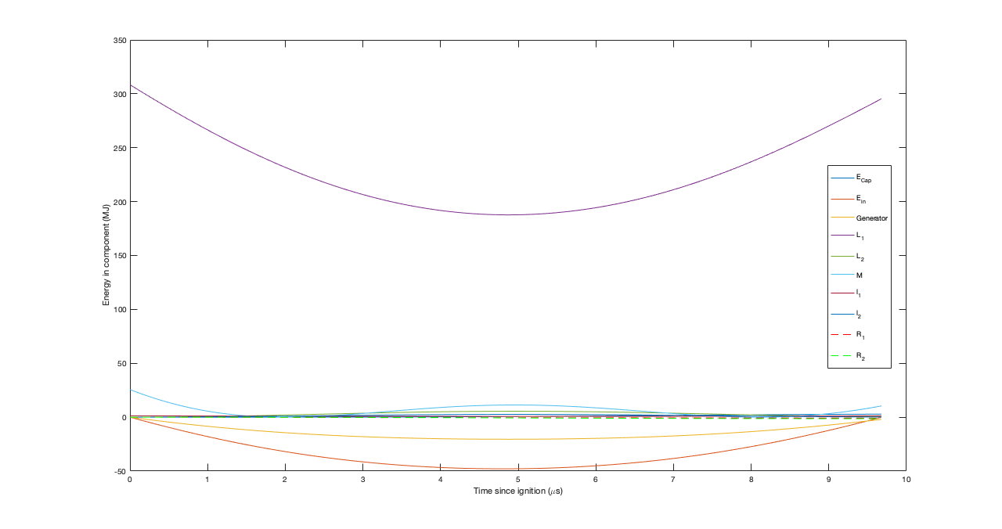

**Figure 2: Energy in circuit by component.**

All graphs are plotted from t=0 to the time at which peak voltage is reached.

Fig. 1 shows that the circuit ends with more energy in it than it starts with, which might make sense as the plasma does work on the circuit ‘system’ raising the total energy of the system, but during what looks like the power stroke, the energy of system components decreases instead of increasing. This doesn’t make sense

Fig. 2 shows that $E_{in}$ is negative, as to be expected, up until the end. When $E_{in}$ is negative, this is the ‘power stroke’ ; when the plasma is doing work on the magnetic field, and thereby the circuit. Energy is being extracted from the plasma this way. Therefore, it could makes sense to stop the integration where the power stroke ends and $E_{in}$ starts going positive, but this results in a Gain of -12.1639

Fowler seems to suggest that the energy the circuit takes out of the plasma, which in Fowler’s case is the energy the generator delivers to the other circuit elements, is given by $E_{circ}=\int{\frac{1}{2}\frac{dL}{dt}I_{1}^{2}}.$ Fowler lists “﻿The negative first term, (I2/2)(DL/dt), clearly is the power delivered by the generator to the other circuit elements” (Fowler, pg. 310 or pg. 6 if you’re looking at the pdf document). Therefore, $E_{circ}=\int{\frac{1}{2}\frac{dL}{dt}I_{1}^{2}}$ or $E_{circ}=\frac{1}{2}\int{I_{1}\tilde{V}dt}$ should give the energy the circuit takes out of the plasma. Performing the numerical integration from t=0 to the time at which peak voltage is reached results in G=0.3743, which is better but still isn’t negative.